

The ultimate low wind NPW type power kite that you can build yourself

Kite version 1.1 December 2004

by Fredrik Lejonklou

~ What is new in version 1.1? ~
Updated instructions and a slight change to bridle B2. Nothing else!

About the Teega

      - Background page 2
      - How does it perform? page 3
      - How do I fly it? page 4
      - What size should I choose? page 4

- How to build your Teega

- Getting the right dimensions page 5
- Cutting and sewing the panels page 6
- Tensioning the trailing edge page 8
- The Teega nose page 9
- T-lines and Extra line page 10
- Bridling your Teega page 10
- Knots page 13

- Building Materials page 14

- Do’s and don’ts page 15

- Advanced options page 16

- Thanks to page 17

About the Teega

Background

The Nasa Para Wing (NPW) kites are extremely popular and it’s not hard to understand why.
First of all, they are cheap to buy and offer a cost-effective way into many power kite sports.
Second, you can easily build one yourself and there are many plans available on the internet.
Third, they pack down small and weigh very little so it’s easy to always have one with you.
Fourth, the time required for setting up to fly is minimal – a minute or two is enough!
Fifth, they are easy to launch, land and relaunch without assistance, regardless of size.
Sixth, they have a massive pull relative to their size.
Seventh, they are virtually unbreakable (but please remember that you are not!).
Eighth, because of their excellent low wind properties, they have a wide wind range.

Advanced kiters, however, often complain about the performance of NPW’s compared to that of the latest foil designs. And it’s true that NPW’s have drawbacks. The main ones are these:
- The pull generated is very strong in the power zone (straight downwind) but small at zenith and to the sides.
- The pull is uneven and hard to control, making the flyer constantly work hard to get the power he or she needs.
- The flying window is smaller than it is with foils, LEI’s and hybrids.
- They can’t be water relaunched.

While I agree that the above is true for many NPW models, the first two points can be considerably improved with a good NPW design. The flying window, however, is a bit smaller, partly because the NPW’s need a certain angle of attack to stay inflated properly but also because they weigh so little that there is no momentum in the kite that helps to expand its flying window when in flight. But the great advantage of the ultra low weight is that they fly in virtually no wind. So even if you prefer flying advanced foils/LEI’s/hybrids, this aspect should make you want at least one (preferably big) in your quiver of kites: It will fly – and pull – when all other power kites refuse to leave the ground!

After more than a year of tuning various NPW9b profiles – I have over 40 well performing profiles from 2003 with explicit comments on my computer – I started summarizing what I had learned so far. Some parameters of the design are fairly fixed while others can be varied and the possible combinations are seemingly endless. The more I studied the data, however, the more I felt I had enough information to make a qualified guess on how to make a better NPW.

The result was named the Teega, a kite that has some unique features:

- A wider single centre panel than any other NPW: 75% of chord.
- A bigger nose than any other NPW: 35% more than the common NPW9b profiles.
- A very clean sail shape for less drag, wind separation and flutter.
- A profile with exceptional pull, speed and stability.
- A slightly cupped trailing edge by tensioning of the reinforcement cord.
- As easy to build as other NPW’s!
How does it perform?

Let me begin by summarizing the two main NPW9b profiles that I made during 2003:
The Buzzard One profile was the first and I use it as a reference since it’s widely spread (it’s the default profile in Jean-Pierre’s NPW9b calculator and the profile that Tom “KiteMan” White currently uses in his downloadable building program). Its main advantage is that it pulls very evenly, regardless of flying direction, and is very smooth and controllable in its behaviour. The flying window is about +-65-70° sideways (a bit more towards zenith) and is largely a compromise between good behaviour and big window. Pushing it another 5-10° is possible but results in the kite becoming nervous, twitchy and generally unpleasant.

The Buzzard Vnose profile (which is available in J-P’s calculator download and can be imported into the program) started with an idea of a different bridling at the nose. The intention was to make the nose less distorted and more stable against collapsing, but after some tuning it became evident that this small change in bridling resulted in a kite that wanted an entirely different bridling to perform at its best. I decided to do it from the beginning again (it does go faster the second time, though ☺) and the result became a kite that is faster and has a slightly bigger window than the Buzzard One; at least +-70° sideways and an amazing ability to park very close to zenith. Improved acceleration and the fact that it is flatter across its width (less cupped) also gives it more “depower”; its flying speed determines the pull to a higher degree than it does with the more constantly pulling Buzzard One. The drawback is that the Vnose profile overall pulls slightly less. A good idea is therefore to increase the planned size about 10%.

The Teega is a different creature altogether. Its flying speed and window is as good as the Vnose profile, but it responds quicker and more precisely to the flyers input. The Teega has an incredibly strong pull which is more evenly distributed across the flying window and holds up better through the turns. Its overhead lift is stronger than any other NPW I have tried so far and the sail also holds its inflated shape better in sudden gusts.

The quick and precise response makes the Teega very well suited for big sizes. In comparison, the Buzzard NPW9b’s feel slower in reaction, more “floaty” and less powerful.

Now go ahead and make one! You will not regret it.
How do I fly it?

The Teega, along with all NPW’s, needs some tension on the brake lines to keep it properly inflated. Eliminating this character in the design of the kite is easy to do, but results in a kite that does not perform at its best. Flying with some tension on the brakes is easy to learn.
How and when the collapse begins differs between various NPW models, however. The Teega is easy to fly in this respect as it is very stable, has a soft way of collapsing (by nose deformation rather than a violent collapse with total loss of power) and never really does anything unexpected.

To turn, you either pull in the brake on one side, which causes a sharp turn. Alternatively, pull on the entire side (power and brake line) for a more gentle turn. Doing one at the left side and the other at the right side causes it to fly sideways! Pulling in both brake lines makes it fly backwards. Like all NPW’s, it is preferably flown with handles, but big ones can also be controlled with a bar (brake lines connected to bar ends). All four flying lines should be equally long.

The “depower” (not true depower because the angle of attack of an NPW can’t be varied) of the Teega works as follows: Flying speed controls the amount of pull. Slowing the kite down by pulling in both brake lines makes it pull less. If you become seriously overpowered, pull hard on the brakes until the kite collapses and flutters around with very little pull, rather than putting yourself in danger. If that is not enough, let go of one handle to make it pull even less.

When the wind is strong, launch and land at an angle instead of straight downwind to reduce the risk of getting overpowered. When landing it can easily be backed down with the trailing edge first (preferably to the side if the wind is strong) or simply flown into the ground nose first. Nothing will break. If it has landed on its nose, it can be restarted backwards by pulling on the brakes until it backs up.

The Teega can be flown on two lines instead of four, but there is little to gain from this except that it’s easier to learn how to fly a kite with two lines. What you loose is the ability to control speed, do sharp turns, reverse starts, safety collapses and much more. I have so far not provided the brake line lengths for a two-line setup. These are, however, easily found by experimentation.

When packing away, the flying lines can simply be rolled up on the handles, all the way up to the kite. When preparing to fly next time, simply lay the kite on the ground and let the lines roll off the handles while you walk away from the kite. With a little practice, this can be done with zero tangles and twists in the lines and the time required for packing up and away is reduced to a few minutes.

What size should I choose?

If you have little or no flying experience with NPW type of kites, the default size of 3.7 square meters, cascade bridled with around 35/20 kg lines is a good choice for your first Teega. It is big enough to fly in very light wind and perfectly manageable in moderate winds. Smaller sizes are faster and bigger ones pull more, both of which can be more demanding on the flyer. Remember that this kite is not suitable for children! Always fly with care – a modest 3.7 sqm NPW can get you seriously injured or even killed in stronger winds!
How to build your Teega

There are many ways to build NPW’s. My favourite assembly methods are Jean-Pierre’s, as described on the building pages of his site (although I do simplify a few steps). Read them when my explanations below are not enough! If you are interested in alternative building methods, check out J-P’s links page. The tips & tricks of Bill Painter and Tom White are interesting; they use faster methods like hot cutting and simplified sewing.
Below you will find my instructions on how to make a Teega, print them out and follow carefully! You really need these instructions because several details differ from the NPW9b.

It is recommended that you adjust the thread tension on your sewing machine so that a seam through 4 layers of ripstop doesn’t wrinkle or curl up the sail.

- Getting the right dimensions
Download J-P’s latest NPW9b calculator (this program runs in Windows only), start the program and import the Teega profile. Change the value of A to the size you want, choose between cascade and standard bridling (see ‘Bridle your Teega’ for advice), copy (Ctrl-C) the window, paste into another program (like Word) and print out this page. I refer to this page as the ‘calculator printout’. All the measurements you need are on this page, with the exception of bridle A1 and the extra line. These two are calculated manually (see ‘T-lines and Extra line’ for details).

Please note, however, that the profile illustration shown in the program is not entirely correct and neither is the AoA or Thickness values. The reason it looks different on the screen is because the Teega uses non-standard sail dimensions that the drawing part of the program misinterprets. Remember that the numbers are all correct; the error is only visual with no consequence to the builder! When designing the Teega, I used a special version of the calculator - thanks, J-P!

The actual profile, with brakes let out to full speed forward, looks like this:

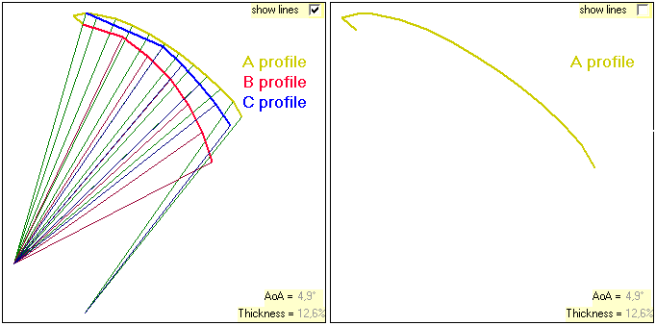

- Cutting and sewing the panels
Although many people recommend hot cutting, a regular cut with a knife or a pair of scissors works fine with high quality ripstop like Chikara.

It is not necessary to cut and sew the nose part of the centre panel, because there is very little stress in this area with the bridling method used on the Teega. The sail is therefore simply made of 3 rectangular pieces, all with the same height: A+4 cm. The +4cm is for the 2 cm edge seam allowances. In between panels, 1.5 cm seam allowance is needed.
The width of the centre panel is B+3 cm.
The width of the ‘2 mid-wings panel’ is C+6.25 cm.
The width of the ‘2 edge-wings panel’ is G+7.25 cm.
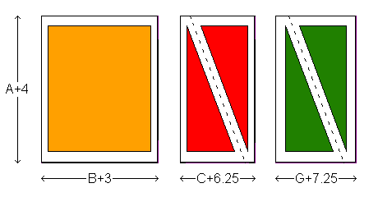
What is easy to get slightly wrong is the diagonal cutting of the wing panels. This is how you should measure at each end to get the correct seam allowances:
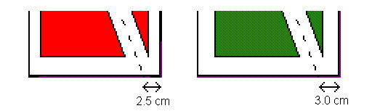

Sew the 5 panels together using the ‘stitch with reinforcement cord’ as described by J-P. To make it easier to sew near the nose corner where seams cross, let the reinforcement line end at H cm from the nose corner in all four seams (see illustration below).
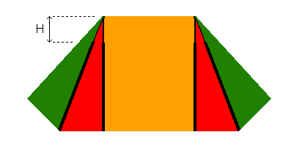
Sew the perimeter of the leading edge and the nose, using the ‘rolled seam with reinforcement cord’ technique as described by J-P. Personally I find just one zigzag stitch is good enough here. In the next illustration, the thick black lines show where you have sewn so far. Do not yet sew the trailing edge!

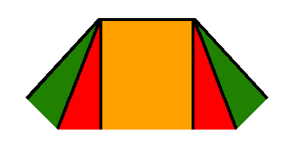

Now take a piece of bridle line (or any other line with little stretch) that is a bit longer than the height A of your kite. With the sail laid out perfectly flat on the floor, have a helper hold one end of the line at the left corner of the nose. If you are working alone, you can tie the line around the leg of a heavy chair and then put the corner of the nose under it.

Take a pen and wind the line around it a few turns so that it is secured with the tip of the pen at the outer wing corner. With the pen, draw a curve from the wing corner to the centre panel and cut this piece off with a pair of scissors. There should be nothing removed from the centre panel or the wing corner, only in between these two points! (If these points are not on equal distance, you will have to remove some fabric from the panel which is longer, so that A=E=F). Do the same thing with the right side of the kite.

The following illustration shows you where to draw and cut:

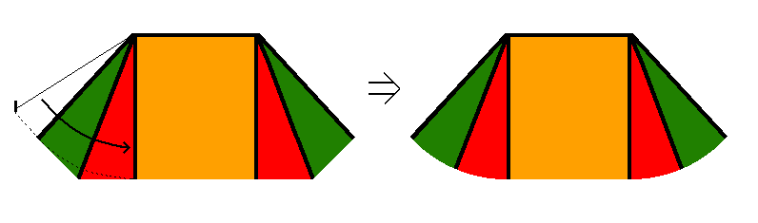
One way of making sure the kite is perfectly symmetrical is to fold it double and copy the left, already cut, wing to the right side.
- Tensioning the trailing edge
In this step you will sew the entire trailing edge, double folded, with a straight stitch and a reinforcement cord lying freely inside it. Make sure that the height of the kite becomes exactly A cm when you are done. Also remember to roll the seam to the same side as you did before, so that all folds end up on the same side.

Starting from the left, sew the trailing edge from the left corner to the centre panel. The reinforcement cord should stick out at both ends but must be secured by a few stitches in the middle (where mid-wing and edge panels meet). The X in the next illustration indicates where the line is secured:
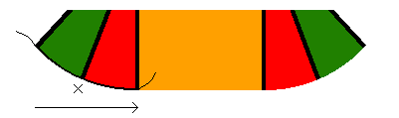
Cut the cord and continue with the centre panel: Secure the end of a new cord (where X is in the illustration below), sew the trailing edge of the centre panel and let the cord stick out where the centre panel ends:
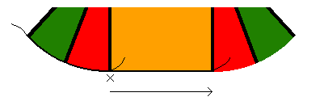
Begin with a new cord and sew all the way to the right corner, with the cord sticking out at both ends. Secure the cord at the middle (X in the next illustration) as you did on the left side. The entire trailing edge is now sewn.
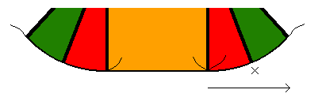

Each of the five panels can now be tensioned by pulling on the free cord ends. This is done by laying the sail out perfectly flat, securing the sail at the point where the cord you are about to pull is fixed (at the X) and very gently pull on the loose end. Just before the sail starts to wrinkle or bend, put a mark where the cord exits from the seam. This mark represents zero tension in that panel. Then pull out the right length (as specified below) and secure the cord with a few stitches or put a knot on the end so it can’t slip back in.

The shortening to make for Teega version 1.0 and 1.1 is: 0.04*B cm on the centre panel and 0.015*A cm on each of the other four panels.

Measure the centre panel width B at the nose of your finished sail, from reinforcement line-in-seam to reinforcement line-in-seam. If B differs from what the calculator printout says, recalculate L=B/6 before drawing the darts in the next step.
- The Teega nose
Carefully draw the 5 nose darts, equally spaced with L cm between each tip, on the front of the sail. The front is the side that has the edge folds on it and will be facing the flyer when in the air. Note that the Teega uses no side darts! Their width is specified as 0.01 cm, because the calculator does not accept zero.
When drawing the nose darts, please make sure that each dart has the exact width K at the very edge of the sail. This is important for the final shape of the nose and the flying performance. When the darts have later been sewn, the nose ”edge” should be exactly 5*K shorter than the ”base” of the nose.

Also draw a line where the nose reinforcement line will be sewn. It runs in a straight line between the tips of the darts (at H cm from the nose edge) and then makes a gently rounded curve at each side, from the last dart tip to a point M cm from the nose corner. See the following diagram (and also the photo on the next page):

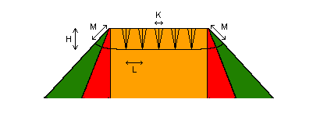

Sew the nose reinforcement line with a straight stitch on the front of the sail, right on the line you just drew. A flat piece of Dacron is easiest to sew, but I usually manage with a 65 kg round Dacron line as well (same as I use in the seams).

Fold each nose dart in the middle, along its central line, and sew with a straight stitch as shown in the next illustration. Make sure you fold them so that the front of the sail is facing out! Note that by not following the triangle line exactly, but instead making the dart slightly bigger in the base and slightly thinner and more ”pointy” towards its tip, there is less distortion of the sail when it’s shaped to a 180° round nose. The drawn straight line should be crossed in the middle. It’s a good idea to draw the S-shaped line before sewing to make things easier.
When all 5 nose darts are sewn, fold them against the sail and secure them at their corners only with a few stitches or a drop of superglue (cyano acrylate glue).
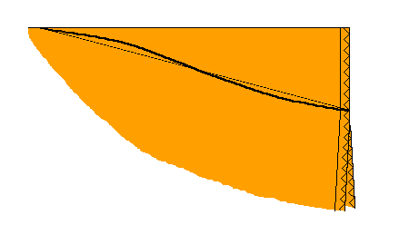
The following picture shows the front side of the first prototype Teega with darts and reinforcement line sewn. Note that both darts and reinforcement line are on this side of the sail – the back side is smooth. The T-lines (2 showing) and the Extra line have been tied (as described in the next step). You can also see bridles A1 (tied to the Extra line), A2 (tied to the sail between orange centre and red mid-wing panel) and B1 (at the right bottom corner).

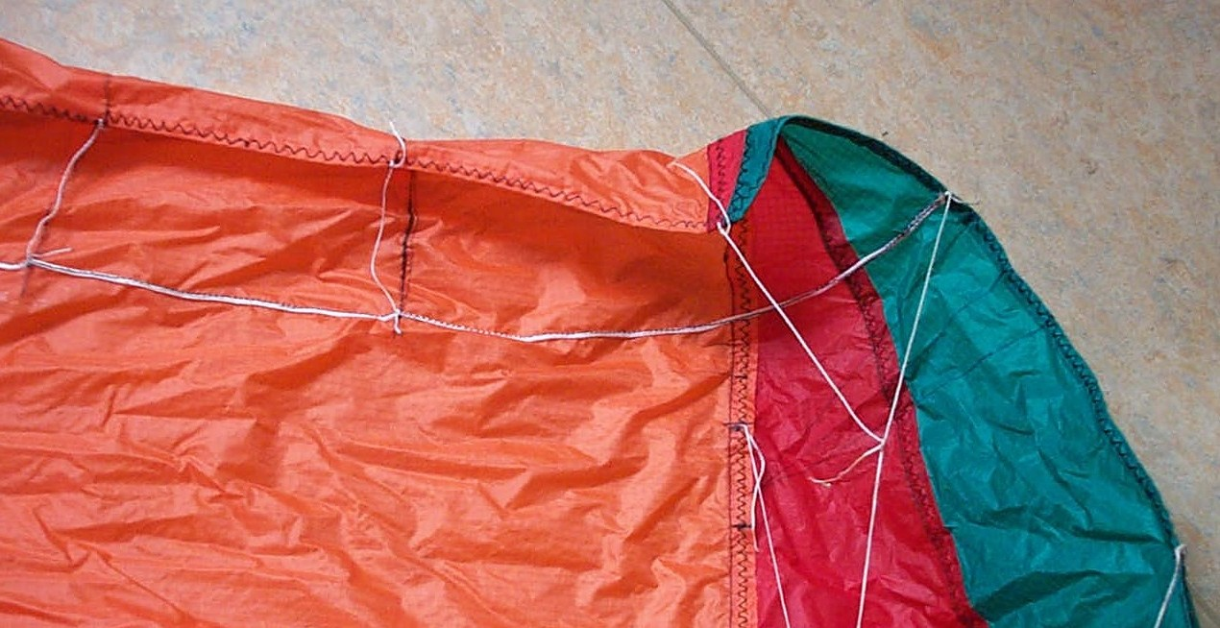

- T-lines and Extra line
The Teega profile requires the use of a ”Vnose arrangement” at each end of bridle A1.

This is done by
- Shortening both bridles A1 by T*1.5. Please do this right away so you don’t forget it: Calculate A1-T*1.5, cross out the value in box A1 on your calculator printout and write the new value beside it.
- Adding two Extra lines, one in each corner of the nose, with the length T*3.3.

Tie the Extra line with one end in the nose corner and the other at M cm towards point B1, right where the sewn reinforcement line ends. Fold it in half and stretch out to measure that it has the right length. Bridle A1 will later be tied around the Extra line with a bridle knot. This knot should be able to slide on the Extra line so that A1 can find its optimal position by itself. The sliding is only needed for the first flight, after it has settled it is an advantage for the stability of the nose if the knot becomes so tight that it can’t move. For this reason, use Dacron for the Extra line rather than Dyneema, which is more slippery.

Tie the 5 T-lines, one at each nose dart, with one end around the reinforcement line and the other end around the edge of the nose, at the fold of the dart. All T-lines should have the length T, carefully measured from the sail beneath the reinforcement line to the nose edge. Note that on the Teega there are no T-lines in the nose corners, only one at each dart. T-lines, Extra line and A1 are all tied with the bridle knot shown under ‘Knots’.

- Bridling your Teega
Mark out all bridle attachment points, using the A-A, B-B and C-C spacing values from your calculator printout. Always measure each point all the way from the trailing edge of the kite, to avoid small errors accumulating. Please note that the top bridle points end up at different distances from the nose (A2 is close, B1 a bit further down and C1 is far away) – this is how it should be!
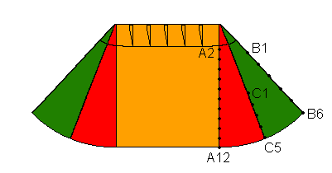

Choose one of two bridling methods:

Standard bridling (non-cascaded) is a bit faster to make and easier to get right. It is the preferred method on really small kites (less than 2.5 square meters), as the measuring errors of a cascade bridling can accumulate and degrade the performance.

Cascade bridling requires more tying of knots and attention to bridle lengths, but it uses less line and will therefore have less drag. The shorter bridles are also easier to measure manually. Make sure your primaries are correct and you won’t ever have to check them in the future. Secondaries can always be adjusted at the sail.

Note that when you bunch and tie the lines together at the Q-point, they get at least 1 cm shorter (depending on the thickness of your lines) – this cm goes into the knot.

Since the Teega uses 3 brake lines (A11, A12 and C5), you have to let one of the primary brake lines run all the way to point C5 while the other goes to the secondary pair A11-A12 when doing cascaded bridling. See illustration below.
With standard bridling, you can run A11-A12 as a pair to the Q-point and C5 as a separate line that goes through the Q-point knot, ending with a stop knot. Always secure the Q-point knots with a few drops of superglue.

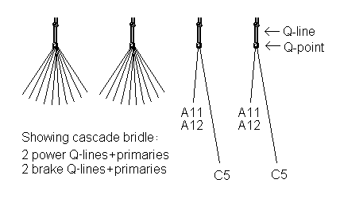
I do the cascaded bridling (the bridling method I prefer) in this order – it may not be the fastest way, but it works well:

1. I cut and tie all the secondaries to the sail, one pair at a time, using the bridle knot shown under ‘Knots’. Each secondary has been marked at the midpoint (where the primary will be attached) and at its correct length. About 5 cm extra is needed at each end for tying it to the sail.

2. I cut all 24 primaries (12 double folded pairs) and bunch them together at the midpoint in four groups; 2 power (5 pairs in each) and 2 brakes (one pair in each). Each pair is marked at its midpoint and at the right length +1 cm (that cm is for the loss in the Q-point knot). All primaries are the same length, except one end of each brake pair that goes all the way to C5, so this step goes much faster. About 2 cm extra is needed at each end for tying it to the secondaries.

3. I cut four 20 cm pieces of thick Dacron (at least 80 kg) – these will become the Q-lines.

4. I tie each bunch of primaries at the midpoint with the Dacron line, which gets folded in two. See knot 2A under ‘Knots’.

5. I make a stop knot on the end of the double folded Dacron and melt the loose ends to a ball shape with a lighter so the knot can’t slip. The Q-lines are now finished!

6. I hang all four Q-lines from a hook in the ceiling.

7. I make a simple stop knot at each primary bridle (except brake C5), at 0.5 cm after the marked primary length distance from the Q-point (about that much disappears into the primary-secondary knot). The stop knot is needed to keep the primary-secondary knot from slipping when under load.

8. I place the kite with its secondary bridles on the floor and tie each primary end to the midpoint of a secondary pair, making sure the primaries are running straight all the way from the Q-point knot without being tangled. See knot 2B under ‘Knots’. Last of all, I tie brake C5 to the sail – note that its length from Q-point to the sail is the sum of primary length and the value in box C5 (if you click on ‘standard bridling’ in J-P’s calculator, the right length will appear in box C5)!

9. Now that everything is in place, I fine-tune the length of the primaries by pulling on the shortest ones until all primaries become equally long. Then I pull hard on all primaries at the same time to make the Q-point knot tight.

10. I put a few drops of glue on each of the four Q-point knots. This is to prevent the primaries from slipping when under load. A drawback with this is that they can’t be replaced one by one, but so far none of my primaries have broken.

11. Done! After a few hours of flying, the secondaries can be measured and re-tuned if necessary. The primaries will not need any adjustment.
- Knots
1. I use the bridle knot shown below for attaching all bridles to the sail (with a needle through all layers of fabric on one side of the reinforcement line and back again on the other side of the reinforcement line). It is also used for tying the T-lines, the Extra line and for attaching A1 to the Extra line. A ”hot tool” for burning small holes in the sail (as described by J-P) is nice but not necessary in my experience.
Remember to tighten this knot by pulling on the right end. If you incorrectly tighten it by pulling on the loose end, the knot will look different and might “twist back” under load, resulting in the bridle getting longer than what you adjusted it to. To adjust the length of a bridle, pull on the loose end and the knot will slide up. It can then be opened up with your nails and adjusted without completely untying it.

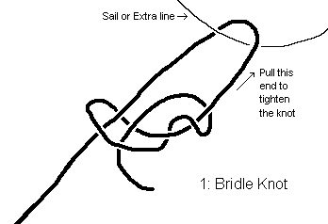

2A. This knot is for attaching bridles to the Q-lines. The black line is the bunch of bridles and the blue is the Q-line, complete with a knot at the end (this is where your flying lines will attach with a larks head knot). Start by gathering all the bridle lines and then make a twist in them. Then tie the Q-line around them as shown. Tighten well and secure the knot with a drop of glue after you have made sure that all bridles have the correct length.
2B. The very same knot is what I use when tying primaries to secondaries on a cascaded bridle. In this case, the black line is the secondary bridle pair and the blue line is the primary. On the end of the primary, you need to put a stop knot or it will slip! I prefer not to glue this knot so that the secondary pair can easily be replaced if necessary. I have broken secondaries, but only by crashing into trees and getting the lines cut by sharp rocks.

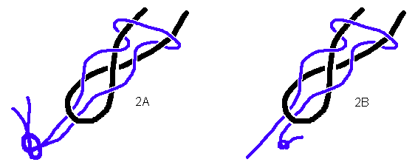

Building materials

Fabric
The Teega has been tested mainly on fabric of Chikara nylon ripstop. This is a high quality material with a little stretch, but not the cheapest to be found. Experiments have shown that stretchier, stiffer or more porous fabrics perform worse and often require a re-tuning of various bridle lengths.
There are many other ripstops to be found, most of them of lower quality than Chikara. One that I have not been satisfied with is nylon Shikarex. It is cheaper but similar to Chikara except for its much stiffer coating. This stiffness results in flutter and more distortion of the nose.

Bridles
The Teega prototypes have all used bridles of Dyneema/Spectra; 25-50 kg for primaries and 15-30 kg for secondaries (the higher numbers are for bigger kites). These are thin low-stretch lines and the best to be found. Dacron is cheaper but stretches more – it will most probably work, but I can’t guarantee that the performance will be as good using this material. Dacron is, however, far easier to untie and is therefore a good choice for secondary bridles (using cascade bridling) if you want to make repeated experiments with different bridle lengths.
The Extra line is preferably made of Dacron, as bridle A1 often moves a bit too easily on the Extra line if they are both made of smooth Dyneema/Spectra.

Reinforcement line
Dacron works great here. I have used 65 and 80 kg strength and have never seen a reinforcement line damaged or broken.
The amount of shortening in the trailing edge seams has been determined using Dacron of this strength. Since it is fairly thick, it is easy to feel where it is and push it where you want it inside the seam while sewing the edges. If you decide to use a less stretchy Dyneema/Spectra line, it is quite likely that it should be shortened just as much. I have, however, not yet tried this.

Sewing thread
Always use synthetic thread. I use ‘extra strong polyester’ which has never failed but is probably overkill and the sewing machine needs to be carefully adjusted to be able to pull it through.

Flying lines
Use only Dyneema/Spectra flying lines. 30m is a very nice length for most kites. Really big ones in smooth wind can benefit from longer and really small ones in gusty conditions can benefit from shorter.
There are many recommendations about flying line strength on the net. Mine (as well as Peter Lynn’s) is to relate to your body weight, regardless of kite size. For main lines, use 2 times your body weight. For brake lines, use your body weight. For really heavy use one can increase this to 3 times body weight for main lines and 1.5 times for brake lines.

Do’s and don’ts

Do stick to Chikara nylon ripstop and bridles of dyneema/spectra if you want your Teega to perform at its best.

Do cut the 3 rectangular pieces of sail with the fabric oriented straight, not diagonally. The ripstop fibres should then run parallel with the A bridle line on both centre & midwing panel and parallel with the leading edge (the B bridle line) on the edge panel.

Do try to be exact when measuring the following: The 5 darts and their T-lines, the Extra line, bridles A1, B1-B6 and the brake lines. These are most critical to the performance of the Teega.

Do try to make the centre, mid-wing and edge panel seams meet at the corner of the nose (after the edge seam has been sewn - this requires the seams to cross slightly just before the corner!). Often it doesn’t end up as a perfect corner because of slight cutting or sewing errors. Small errors are ok, but make sure that the Extra line is attached with one end at the corner of the centre panel and the other at the distance M cm from this point down along the leading edge.

Do check your finished sail dimensions if you are unsure: The height should be A=E=F and the distance between bridle points B6 and A12 should be 0.765*A, on both sides. If this last dimension is not right and your nose corner is less than perfect, consider re-sewing the leading edge on both sides (from nose corner to where bridle B6 attaches) to get the sail dimensions closer to the ideal. It’s very little work and will pay off with better performance.

Do sew the perimeter (edge) of the sail before making the darts. This will make your dart measurements more exact and allow you to re-sew them if they are not.

Do remember that a regular knot is a lot easier to untie and adjust than a nicer looking loop-through-centre-of-the-core attachment. The short loose ends aren’t really visible when flying.

Do experiment with the Teega profile if you feel like it, but keep in mind that its default values are thoroughly tested and should perform well without any adjustments.

Do contact me if you’re having problems: lejonklou@hotmail.com
I’d also very much appreciate a short email or a picture when you’ve successfully built one!

Don’t use ‘Q-point extensions’ as they will alter the shape of the kite.

Don’t hot cut and discard the darts as it becomes impossible to alter their shape afterwards.

Don’t try to manually calculate the bridle attachment points by dividing the height of the sail with the number of bridles in that row. Always use the spacing values from J-P’s calculator and mark out the points by measuring each point all the way from the trailing edge.

Advanced options

Centre panel width

Experiment with the NPW9b in 2003 showed that a wider centre panel (B=A*2/3) had more wing properties and less parachute properties than a narrow centre panel (B=A/2). The result was a kite that was more fun to fly and performed better in terms of power control. The Teega takes this one step further by increasing the centre panel width to B=A*3/4.

Some people still prefer a narrow centre panel for aesthetic reasons. In case you feel that way or wish to experiment with even wider centre panels, there is no reason why you shouldn’t build your Teega with the centre panel width of your choice. Fact is that this change can be made with little or no adjustment to the profile. My guess is that the Teega will perform reasonably well with centre panel widths between B=A/2 and B=A.

What is important to know is that the only sail measurement that needs adjustment is L. Calculate it as L=(centre panel width)/6. The number of darts, their width K and all other values remain unchanged!

If you do choose to build a Teega with an altered centre panel width, I would be happy if you let me know, regardless of whether you need help adjusting it or it flies perfectly.
Contact me at: lejonklou@hotmail.com

Trailing edge tensioning

The tensioning of the trailing edge, created by the shortening of the reinforcement line, contributes to the high quality power and stability of the Teega. The amount of shortening is a good compromise determined by flying in different conditions. Altering this value affects the performance, so if you wish you can make it adjustable. Tightening it further increases the power, but makes the kite slower and more prone to stalling, which can limit its performance in light winds. Decreasing the tension makes the Teega slightly faster at the expense of stability and power.

If you decide to decrease the tension, start by reducing the shortening of the reinforcement line to 50% of the default values to get an idea of what it does. The Teega will fly with no trailing edge tensioning, but will be twitchy and prone to nose collapse in gusty winds because of its low angle of attack.

Adding different amounts of tension to the edge, mid-wing and centre panels is of course possible for those wishing to experiment further. It is, however, complicated to evaluate as you will have to keep records on which setting did what in various wind conditions.
Thanks to

Jean-Pierre Gleyzes – for his willingness to always add yet another useful feature to his excellent NPW9b design tool: The Nasa Para Wing 9b calculator. Also many thanks for his great NPW pages and, of course, for hosting these pages about the Teega!

Bill “NPWBill” Painter, alias NPWBill – for designing the NPW9b by using Francis Rogallo’s 9th model in the Nasa Para Wing series. This was before the similarly looking commercial NPW9 was released and the ‘b’ in the name was later added by Bill to avoid confusion.

Tom “KiteMan” White – for spreading the NPW9b kite to enthusiast around the globe with his excellent step-by-step building program and for his clever tips on how to build NPW’s.

Terence Kearey – for putting me on the right track when designing wing profiles with his explanations of laminar separation bubbles and what causes them. Also for his in-flight videos of the NPW9b Buzzard Vnose that made it possible to study the differences between theoretical profiles and how they actually look in flight.

Fred Cramer – for putting me straight on the not-straight sewing method of the nose darts.

Jan Claes – for his endless experiments with new NPW ideas; triple centre panel, high aspect, different bridling, progressive brakes, you name it!

Larry Green – for his early experiments with the length of the NPW9b T-lines, that inspired me to make the nose increasingly fatter.

Dave Culp – for bringing the benefits of tension along the trailing edge to my attention.

Francis Rogallo, the father of the Nasa Para Wing parachutes, whose work pioneered the making of flexible flying wings.

… and to everyone else at the discussion group npw9b@topica.com!

